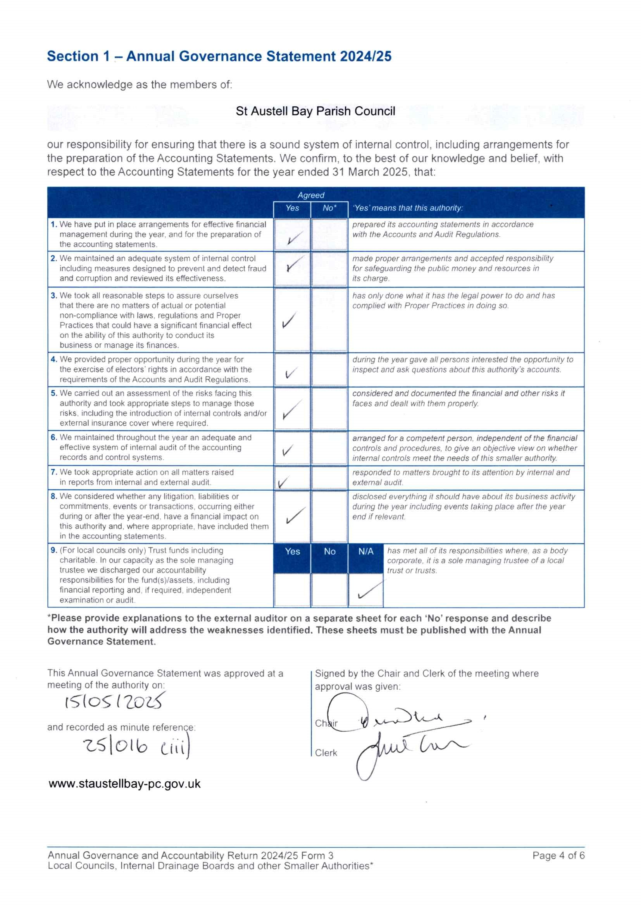

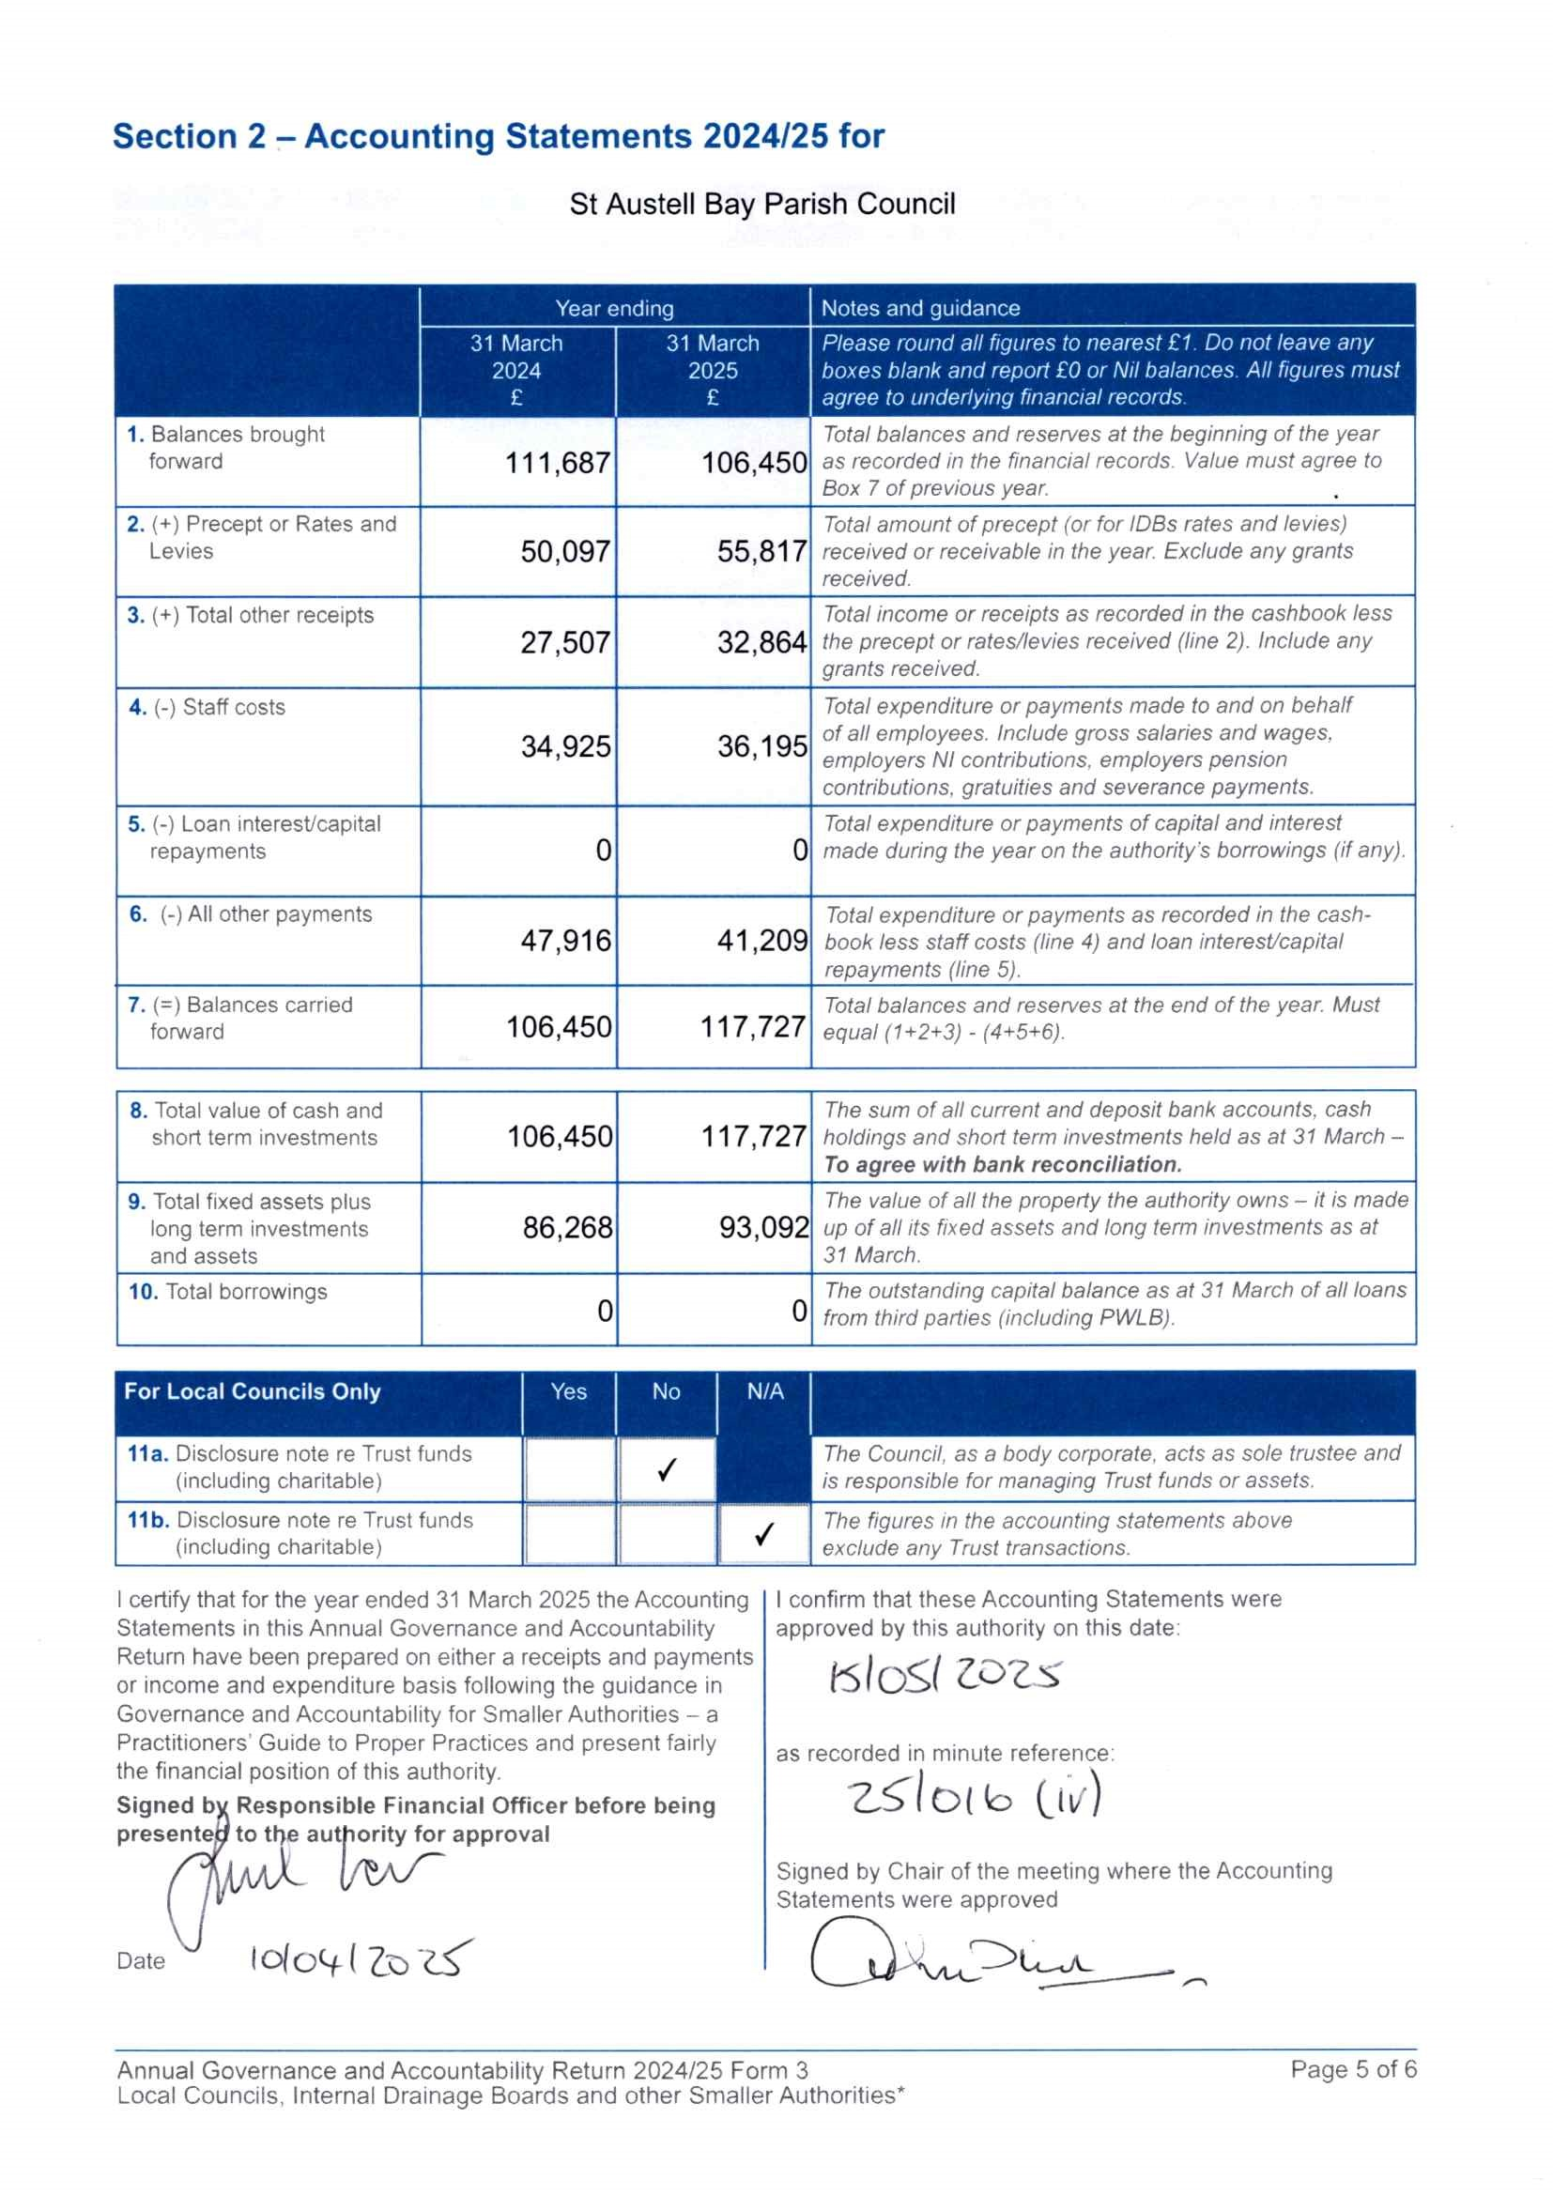

**Section 3 – External Auditor’s Report and Certificate 2024/25**

|  |
| --- |
| **ENTER NAME OF AUTHORITY**St Austell Bay Parish Council |

In respect of

# Respective responsibilities of the auditor and the authority

Our responsibility as auditors to complete a **limited assurance review** is set out by the National Audit Office (NAO). A limited assurance review is **not a full statutory audit,** it does not constitute an audit carried out in accordance with International Standards on Auditing (UK & Ireland) and hence it **does not** provide the same level of assurance that such an audit would. The UK Government has determined that a lower level of assurance than that provided by a full statutory audit is appropriate for those local public bodies with the lowest levels of spending.

Under a limited assurance review, the auditor is responsible for reviewing Sections 1 and 2 of the Annual Governance and

Accountability Return in accordance with NAO Auditor Guidance Note 02 (AGN 02 as issued by the NAO on behalf of the Comptroller and Auditor General. AGN 02 is available from the NAO website – https://www.nao.org.uk/code-audit-practice/guidance-and-information-for-auditors/ .

This authority is responsible for ensuring that its financial management is adequate and effective and that it has a sound system of internal control. The authority prepares an Annual Governance and Accountability Return in accordance with *Proper Practices* which:

* summarises the accounting records for the year ended 31 March 2025; and
* confirms and provides assurance on those matters that are relevant to our duties and responsibilities as external auditors.

# External auditor’s limited assurance opinion 2024/25

On the basis of our review of Sections 1 and 2 of the Annual Governance and Accountability Return, in our opinion the information in Sections 1 and 2 of the Annual Governance and Accountability Return is in accordance with Proper Practices and no other matters have come to our attention giving cause for concern that relevant legislation and regulatory requirements have not been met.

(continue on a separate sheet if required)

|  |
| --- |
| Other matters not affecting our opinion which we draw to the attention of the authority:  None  (continue on a separate sheet if required) |

# External auditor certificate 2024/25

We certify that we have completed our review of Sections 1 and 2 of the Annual Governance and Accountability Return, and discharged our responsibilities under the Local Audit and Accountability Act 2014, for the year ended 31 March 2025.

External Auditor Name

**ENTER NAME OF EXTERNAL AUDITOR**BDO LLP - Southampton

**DD/MM/YYYY**

**SIGNATURE REQUIRED**

Date

External Auditor Signature

13

2025

August

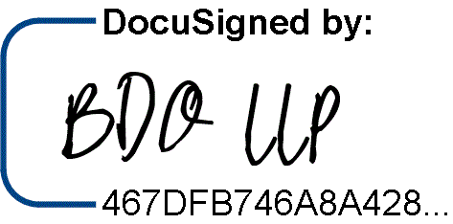

Annual Governance and Accountability Return 2024/25 Form 3 Page 6 of 6

Local Councils, Internal Drainage Boards and other Smaller Authorities*